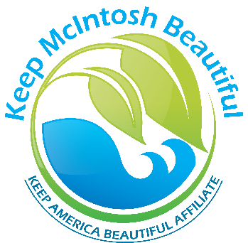

Adopt-A-Highway Program Information Sheet

**KMB Adopt-A-Highway/Park/Spot Program:** Stewardship starts at home, in your neighborhood. The KMB Adopt-A-Highway Program is a community appearance enhancement program. The idea is to create public interest and support for litter control on local roadways and streets and other public spaces in our community. KMB’s goal is to make McIntosh County a cleaner, greener community that will not only boost local pride and make this a better place to live, work and play, but can increase tourism, improve local commerce and attract new residents to the county. You can choose to make a difference and help assure a cleaner environment for you and your family.

**Purpose:** The KMB Adopt-A-Highway Program promotes public involvement in the maintenance and/or improvement of “adopted” areas. By engaging individuals, organizations and businesses to take greater responsibility for improving our community surroundings we can prevent litter, reduce waste and beautify McIntosh County. All major litter research studies show that litter decreases in areas where the community has taken a personal responsibility for maintaining those areas. Evidently, it is easier for some people to litter when they think that no one cares. The KMB Adopt-A-Highway/Park/Spot Program shows that someone cares.

**Who can adopt?** Anyone can adopt; individuals, families, neighborhood groups, neighborhood organizations, civic organizations, youth groups, school groups, church groups and businesses. Honor a loved one or a personal or hometown hero. A sign with the name you choose will be put up at the mile or site you’ve adopted.

**Responsibilities:** Adoptees agree to commit for a minimum of two years (24 consecutive months), pick-up trash a minimum of four times a year, submit a Pick-up Report Form for *every* pick-up and maintain current contact information with KMB. The Pick-up Report Form is available on our website: [www.keepmcintoshbeautiful.com](http://www.keepmcintoshbeautiful.com), or can be mailed to you.

**How to Adopt-A-Highway:** Simply download an Adopt-A-Highway Registration and Contract form from our website: www.keepmcintoshbeautiful.com Print it, fill it out and mail to: Keep McIntosh Beautiful, P.O. Box 2055, Darien, GA 31305. You can also request an application be mailed to you. After receiving it, we will contact you right away to finalize the adoption process. *Questions?* Contact Tracy at [keepmcintoshbeautiful@gmail.com](mailto:keepmcintoshbeautiful@gmail.com) or 912-289-1083.

Thank you for your interest in our Adopt-A-Highway Program.

Working Together for a Clean, Green and Beautiful McIntosh County, Georgia!

[www.keepmcintoshbeautiful.com](http://www.keepmcintoshbeautiful.com)